Multiple-choice section

|  |  |  |  |  |  |  |  |  |  |
| --- | --- | --- | --- | --- | --- | --- | --- | --- | --- |
| Question | 1 | 2 | 3 | 4 | 5 | 6 | 7 | 8 | 9 |
| Answer | C | B | B | C | A | D | A | B | D |

Question 1 [2.6] [10A]­­­

**C**

10A: mean = 

10B: mean = 

Question 2 [2.3]

**B**

As the minimum temperature reached may not have occurred at one of the times when the measurements were recorded we cannot say with any certainty what that value would have been.

Question 3 [2.5]

**B**

QL = 2, median = 3 and QU = 5.5

Question 4 [2.2]

**C**

There is no apparent linear trend.

Question 5 [2.2]

**A**

II is the only correct plot. The others show an outlier too close to the box.

Question 6 [2.2]

**D**

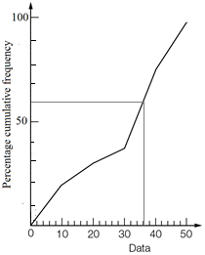

Question 7 [2.1]

A

IQR = 32 – 22 = 10

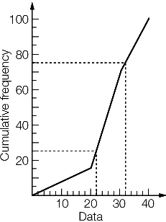

Question 8 [2.2]

B

IQR = 51 − 23 = 28 ∴ C is correct

1.5 × IQR = 42 ∴ A is correct

42 is the median ∴ D is correct

About 75% of values lie below the upper quartile, which is 51 ∴ B is incorrect

Question 9 [2.8] [10A]­­

**D**

Mean ≈ 4.6, standard deviation ≈ 3.07

Multiple-choice total marks: 9

Short answer section

Question 10 3 marks [2.1–2.7]

(a) A cumulative frequency curve can be used to find the five-number summary from a set of continuous data that is presented in grouped form.

(b) An outlier is a value that is significantly lower or higher than the majority of values in a data set.

Question 11 10 marks [2.1]

**(a)** **(i)** 2 4 4 6 7 | 13 15 15 18 24

|  |  |  |  |  |
| --- | --- | --- | --- | --- |
| Lowest | QL | Median | QU | Highest |
| 2 | 4 | 10 | 15 | 24 |

**(ii)** Mean = 

(b) (i)

|  |  |  |  |  |
| --- | --- | --- | --- | --- |
| Lowest | QL | Median | QU | Highest |
| 56 | 58 | 59 | 60 | 60 |

(ii)

|  |  |  |  |
| --- | --- | --- | --- |
| x | f | x × f | Cumulative  frequency |
| 56 | 3 | 168 | 3 |
| 57 | 2 | 114 | 5 |
| 58 | 12 | 696 | 17 |
| 59 | 20 | 1180 | 37 |
| 60 | 15 | 900 | 52 |
| Total | 52 | 3058 |  |

Mean =  ( 1 d.p.)

Question 12 5 marks [2.3]

(a) Set A: (i) median = 3 (ii) range = 5 − 1 = 4 (iii) IQR = 4 − 2 = 2  
Set B: (i) median = 2 (ii) range = 5 − 0 = 5 (iii) IQR = 4 − 0.5 = 3.5

(b) Set A values are higher on average. Set B data is more spread out than Set A. The lowest value is in Set B and they share the highest value.

Question 13 3 marks [2.5]

**(a)**

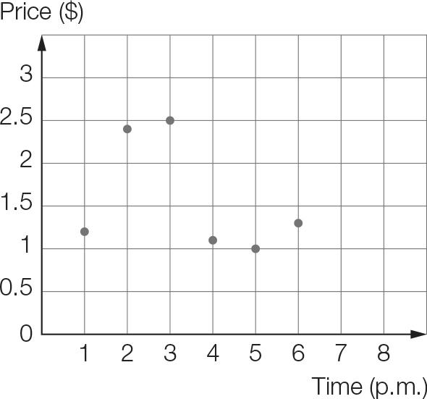

**(b)** At 1 pm the price started at $1.20 then rose significantly through to 2 pm, where the price had doubled. The price then increased over the next hour, before dropping to its initial level then increasing slightly for the final 2 hours.

Question 14 10 marks [2.2]

**(a)** Put the data in order as a first step:

1866 1866 1866 1908 1931 1934 1934 1942 1944 1944 1945 1945

1947 1950 1953 1954 1954 1955 1955 1956 1961 1963 1968 1974

lower quartile, QL: 1934

median: 1946

upper quartile, QU: 1955

IQR = 1955 − 1934 = 21 years

**(b)**

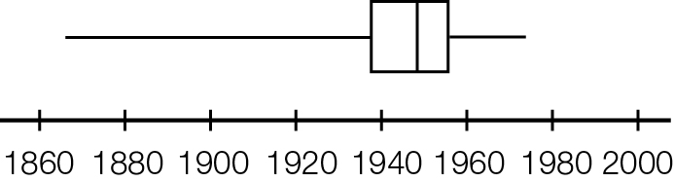

Question 15 5 marks [2.7]

**(a)** The bars are labelled as specific days, spread inconsistently over a 13-day gap. The third bar represents a time period of two days.

**(b)** The longest match Selena played with the sixth, which went for approximately 185 minutes, the previous match was the shortest, it was over in less than 40 minutes.

**(c)** The match may have been postponed due to bad weather.

**(d)** Total number of minutes of tennis:  
60 + 75 + 100 + 165 + 35 + 185 + 140 = 760  
Divide by the number of matches:   
60 ÷ 7 ≈ 109   
Approximately 109 minutes or 1 hour and 49 minutes per match.

Short answer results: ___ / 36

Extended answer section

Question 16 8 marks [2.1]

|  |  |  |  |
| --- | --- | --- | --- |
| Weight (kg) | Frequency | Data  value | Cumulative  frequency |
| <64 | 0 | 64 | 0 |
| 64−<66 | 1 | 66 | 1 |
| 66−<68 | 6 | 68 | 7 |
| 68−<70 | 10 | 70 | 17 |
| 70−<72 | 17 | 72 | 34 |
| 72−<74 | 11 | 74 | 45 |
| 74−<76 | 10 | 76 | 55 |
| 76−<78 | 6 | 78 | 61 |
| 78−<80 | 5 | 80 | 66 |

(a)

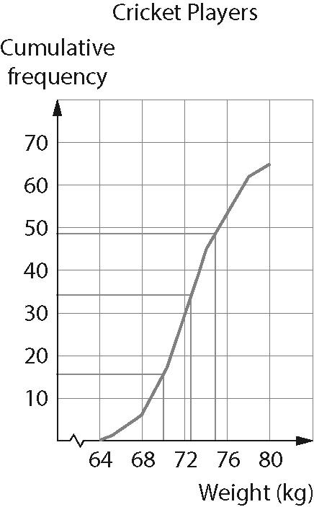

(b)

|  |  |  |  |  |
| --- | --- | --- | --- | --- |
| Min | QL | Median | QU | Max |
| 64 | 70 | 72 | 75 | 80 |

(c)

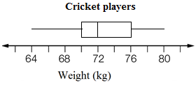

Question 17 5 marks [2.4, 2.6] [10A]­­

|  |  |  |  |  |  |  |  |  |
| --- | --- | --- | --- | --- | --- | --- | --- | --- |
| English | 28 | 50 | 25 | 27 | 42 | 38 | 40 | 22 |
| Maths | 48 | 50 | 32 | 36 | 48 | 44 | 42 | 47 |

**(a)** *y* = 0.32*x* + 32.41

(b)

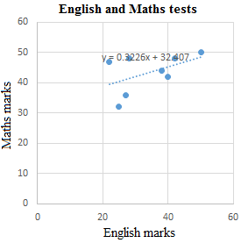

**(c)** Maths mark = English mark × 0.32 + 32.41

**(d)** Maths mark = 34 × 0.32 + 32.41 = 43.29  
The predicted mark for Maths is 43.

Question 18 10 marks [2.1, 2.3]

City X: 4.5 5.1 5.1 6.4 7.1 7.8 9.1 9.3 10.8 11 12 12   
City Y: 4 5.1 5.9 8.2 9.7 12.5 14.8 17.4 17.9 20.2 20.6 21.2

**(a)** City X: min = 4.5 Q1 = 5.75 median = 8.45 Q3 = 10.9 max = 12  
City Y: min = 4 Q1 = 7.05 median = 13.65 Q3 = 19.05 max = 21.2

**(b)**

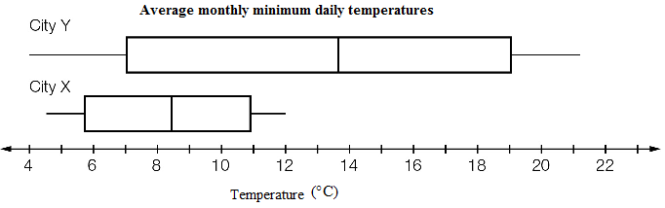

**(c)** The temperatures for City Y are, on average, higher, and more widely spread than for City X.  
City Y has the highest temperature by far, but the lowest temperatures are almost the same.

Question 19 7 marks [2.1, 2.3]

|  |  |  |  |  |  |  |  |  |  |  |  |  |  |  |  |  |  |  |  |  |  |  |  |  |  |  |  |  |  |  |  |  |  |  |  |  |  |  |  |  |  |  |  |  |  |  |  |  |  |  |  |  |  |  |  |  |  |  |  |  |  |  |  |  |  |  |  |  |  |  |  |  |  |  |  |  |
| --- | --- | --- | --- | --- | --- | --- | --- | --- | --- | --- | --- | --- | --- | --- | --- | --- | --- | --- | --- | --- | --- | --- | --- | --- | --- | --- | --- | --- | --- | --- | --- | --- | --- | --- | --- | --- | --- | --- | --- | --- | --- | --- | --- | --- | --- | --- | --- | --- | --- | --- | --- | --- | --- | --- | --- | --- | --- | --- | --- | --- | --- | --- | --- | --- | --- | --- | --- | --- | --- | --- | --- | --- | --- | --- | --- | --- |
| (a)   |  |  |  | | --- | --- | --- | | x | f | x × f | | 1 | 3 | 3 | | 2 | 3 | 6 | | 3 | 6 | 18 | | 4 | 2 | 8 | | 5 | 4 | 20 | | 6 | 2 | 12 | | 7 | 3 | 21 | | 8 | 0 | 0 | | 9 | 1 | 9 | | 10 | 1 | 10 | | Total | 25 | 107 |   Mean =  ≈ 4.3  On average 4.3 games won by the winning teams. | (b)   |  |  |  | | --- | --- | --- | | x | f | x × f | | 0 | 5 | 0 | | 1 | 3 | 3 | | 2 | 3 | 6 | | 3 | 6 | 18 | | 4 | 2 | 8 | | 5 | 4 | 20 | | 6 | 2 | 12 | | 7 | 3 | 21 | | 8 | 0 | 0 | | 9 | 1 | 9 | | 10 | 1 | 10 | | Total | 30 | 107 |   Mean =  ≈ 3.6  On average 3.6 games won by all teams. |

Question 20 10 marks [2.3, 2.8]

(a)

|  |  |
| --- | --- |
| Weight (kg) | Frequency |
| 50–<55 | 12 |
| 55–<60 | 7 |
| 60–<65 | 7 |
| 65–<70 | 8 |
| 70–<75 | 6 |

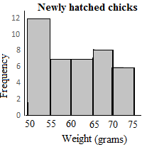

(b) The data in order:

52 52 52 53 53 53 53 54 54 54 | 54 54 55 55 56 57 57 57 58 60

60 61 63 63 63 64 65 65 65 65 | 66 67 67 67 70 71 72 73 73 74

|  |  |  |  |  |
| --- | --- | --- | --- | --- |
| Min | QL | Median | QU | Max |
| 52 | 54 | 60 | 65.5 | 74 |

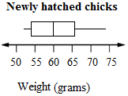

(c)

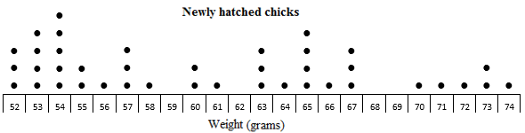

**(d)** The dot plot has the raw data so you can see exactly how many of each weight. The weights range from 52 g to 74 g with five chicks at 54 g. The histogram shows a fairly uniform distribution apart from a peak at the lowest weight range. Weights are from 50 g to 75 g. The box plot shows the weights from 52 g to 74 g with amounts more spread out for the higher weights.

[10A]­­ **(e)** From a calculator: Mean ≈ 60.7 g, SD ≈ 6.84 g

Extended answer results: ___ / 40

TOTAL test results: ___ / 85